NATIONAL INSTITUTE OF TECHNOLOGY KARNATAKA SURATHKAL (MANGALORE)



COMPILER DESIGN PROJECT
REPORT 1 – LEXICAL ANALYSIS

TEAM MEMBERS : -
KAPIL VASHIST (15CO123)
GAUTHAM M (15CO118)

INTRODUCTION TO COMPILER

A Compiler is a language translator. It converts any high level language code into an equivalent and correct machine level language code.

A Compiler can be broadly divided into two phases :-
1. Analysis Phase
2. Synthesis Phase

ANALYSIS PHASE | SYNTHESIS PHASE
1. Lexical Analysis  2. Syntactical Analysis  3. Semantic Analysis  4. Intermediate Code Generation | 1. Code Optimization  2. Code Generation
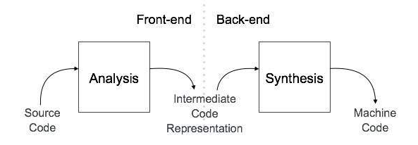

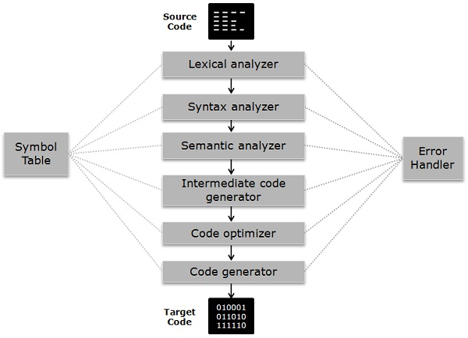

LEXICAL ANALYSIS : -

Lexical analysis is the first phase of a compiler. It takes the modified source code from language preprocessors that are written in the form of sentences. The lexical analyzer breaks these syntaxes into a series of tokens, by removing any whitespace or comments in the source code.
If the lexical analyzer finds a token invalid, it generates an error. The lexical analyzer works closely with the syntax analyzer. It reads character streams from the source code, checks for legal tokens, and passes the data to the syntax analyzer when it demands.
Lexical Analyser (FSM)
Parser
Lexical
Errors
Regular Expression
Source Program in HLL
Symbol Table
Insert Symbol
Token
getToken()

Lexemes are said to be a sequence of characters (alphanumeric) in a token. There are some predefined rules for every lexeme to be identified as a valid token. These rules are defined by grammar rules, by means of a pattern. A pattern explains what can be a token, and these patterns are defined by means of regular expressions.
In programming language, keywords, constants, identifiers, strings, numbers, operators and punctuations symbols can be considered as tokens.
For example, in C language, the variable declaration line
int value = 100;
contains the tokens:
int (keyword), value (identifier), = (operator), 100 (constant) and ; (symbol).

Longest Match Rule
When the lexical analyzer read the source-code, it scans the code letter by letter; and when it encounters a whitespace, operator symbol, or special symbols, it decides that a word is completed.
For example:
int intvalue;
While scanning both lexemes till ‘int’, the lexical analyzer cannot determine whether it is a keyword int or the initials of identifier int value.
The Longest Match Rule states that the lexeme scanned should be determined based on the longest match among all the tokens available.
The lexical analyzer also follows Rule Priority where a reserved word, e.g., a keyword, of a language is given priority over user input. That is, if the lexical analyzer finds a lexeme that matches with any existing reserved word, it should generate an error.

Source Code:

%{
#include<stdio.h>
#include<string.h>
int c=0;
int l=0;
int comment_stack[100];//for storing comment stack
int stacktop=-1;//top of comment stack
int commentflag=0;//check if thing is inside commnet
//hash function
unsigned long hash(unsigned char *str)
{
unsigned long hash = 5381;
int c;

while (c = *str++)
hash = ((hash << 5) + hash) + c; /* hash * 33 + c */

return hash;
}

//symbol table
struct symbol{
int valid;
char name[100];
char type[100];
int lineno[100];
int linecount;
struct symbol *next;
} symboltable[65535];

//constants table
struct constants{
int valid;
char name[100];
char type[100];
int lineno[100];
int linecount;
struct constants *next;
} constantstable[65535];

//no of constants
int countconstants=0;
int countsymbol=0;

//function to add symbol to symbol table
void push_to_symbol_table(char ctemp[],unsigned long map,char type[])
{
if(symboltable[map].valid==1&&strcmp(symboltable[map].name,ctemp)==0) //case when the symbol is already in table first
{

symboltable[map].lineno[symboltable[map].linecount]=l;
symboltable[map].linecount++;

}
else if(symboltable[map].valid==1&&strcmp(symboltable[map].name,ctemp)!=0)//case when symbol not in table first
{
int found=0;
struct symbol * pointer=&symboltable[map];
while(pointer->next!=NULL)
{
if(strcmp(pointer->name,ctemp)==0)
{
found=1;
}
pointer=pointer->next;
}
if(found==0)////case when symbol not found
{
struct symbol * tempsymbol;
strncpy(tempsymbol->name,yytext,yyleng);
strcpy(tempsymbol->type,type);
tempsymbol->linecount=0;
tempsymbol->valid=1;
tempsymbol->next=NULL;
tempsymbol->lineno[tempsymbol->linecount]=l;
tempsymbol->linecount++;
pointer->next=tempsymbol;
}
if(found==1)//case when symbol found at some other position
{
pointer->lineno[pointer->linecount]=l;
pointer->linecount++;

}

}
else{ //hashtable map is free
strncpy(symboltable[map].name,yytext,yyleng);
strcpy(symboltable[map].type,type);
symboltable[map].linecount=0;
symboltable[map].valid=1;
symboltable[map].next=NULL;
symboltable[map].lineno[symboltable[map].linecount]=l;
symboltable[map].linecount++;
++countsymbol;
}
}

//function to add constants to constant table
void push_to_constants_table(char ctemp[],unsigned long map,char type[])//case when the symbol is already in table first
{
if(constantstable[map].valid==1&&strcmp(constantstable[map].name,ctemp)==0)
{
constantstable[map].lineno[constantstable[map].linecount]=l;
constantstable[map].linecount++;

}
else if(constantstable[map].valid==1&&strcmp(constantstable[map].name,ctemp)!=0)//case when symbol not in table first
{
int found=0;
struct constants * pointer=&constantstable[map];
while(pointer->next!=NULL)
{
if(strcmp(pointer->name,ctemp)==0)
{
found=1;
}
pointer=pointer->next;
}
if(found==0)////case when symbol not found
{
struct constants * tempconstants;
strncpy(tempconstants->name,yytext,yyleng);
strcpy(tempconstants->type,type);
tempconstants->linecount=0;
tempconstants->valid=1;
tempconstants->next=NULL;
tempconstants->lineno[tempconstants->linecount]=l;
tempconstants->linecount++;
pointer->next=tempconstants;
}
if(found==1)//case when symbol found at some other position
{
pointer->lineno[pointer->linecount]=l;
pointer->linecount++;

}

}
else{//hashtable map is free
strncpy(constantstable[map].name,yytext,yyleng);
strcpy(constantstable[map].type,type);
constantstable[map].linecount=0;
constantstable[map].valid=1;
constantstable[map].next=NULL;
constantstable[map].lineno[constantstable[map].linecount]=l;
constantstable[map].linecount++;
++countconstants;
}
}

%}
preprocessordirective #.*
single_line_comments \/\/.*
multi_line_comments_start \/\*
multi_line_comments_end \*\/
space [\ ]|\t
line \n
openparanth [{]
closeparanth [}]
strings ["].*["]
keyword void|for|do|while|if|else|return|auto|break|case|char|const|continue|default|double|enum|extern|float|goto|if|int|long|register|return|short|signed|sizeof|static|struct|switch|typedef|union|unsigned|volatile
intconst [0-9]+
floatconst [0-9]+[\.][0-9]+
charconst [a-z|A-Z]
functions [a-z][a-zA-Z0-9]*\(.*\)
specialsymbols \(|\)|\]|\[|,
delimitter ;
Operator [\+|-|=|/|\*|%]
notIdentifier [^a-zA-Z\t\n\ "\(|\)|\]|\[|,|"|\+|\-|=|/|\*|%|>|<|&|\||_|;][a-zA-Z0-9]*[a-zA-Z][a-zA-Z0-9]*
identifier [a-z][a-zA-Z0-9]*
error .
%%
{line} {
++l;//increment line count
}
{space} {}
{preprocessordirective} {
if(commentflag==0){
char ctemp[100];
strncpy(ctemp,yytext,yyleng);
unsigned long map=hash(ctemp);
map=map%65535;
push_to_symbol_table(ctemp,map,"pre processor directory");
memset(&ctemp[0], 0, sizeof(ctemp));
}
else
{
printf("%s",yytext);
}

}
{openparanth} {
if(commentflag==0){
char ctemp[100];
strncpy(ctemp,yytext,yyleng);
unsigned long map=hash(ctemp);
map=map%65535;
push_to_symbol_table(ctemp,map,"openParanthesis");
memset(&ctemp[0], 0, sizeof(ctemp));
}
else
{
printf("%s",yytext);
}
}

{closeparanth} {
if(commentflag==0){
char ctemp[100];
strcpy(ctemp," ");
strncpy(ctemp,yytext,yyleng);
unsigned long map=hash(ctemp);
map=map%65535;
push_to_symbol_table(ctemp,map,"closeparanthesis");
memset(&ctemp[0], 0, sizeof(ctemp));
}
else
{
printf("%s",yytext);
}
}
{multi_line_comments_start} {
stacktop++;
comment_stack[stacktop]=1;
commentflag=1;
printf("comment start at %d :",l);
}
{multi_line_comments_end} {
if(stacktop==-1){
printf("comment error at %d \n", l);
}
else{
stacktop--;
if(stacktop==-1)
{
printf("comment end at %d \n", l);
commentflag=0;
printf("\n");
}
}
}
{single_line_comments} {
if(commentflag==0){
printf("comment :%s at %d\n",yytext,l);

}
else
{
printf("%s",yytext);
}
++l;
}

{intconst} {
if(commentflag==0){
char ctemp[100];
strcpy(ctemp," ");
strncpy(ctemp,yytext,yyleng);
unsigned long map=hash(ctemp);
map=map%65535;
push_to_constants_table(ctemp,map,"integer constant");
memset(&ctemp[0], 0, sizeof(ctemp));
}
else
{
printf("%s",yytext);
}
}
{floatconst} {
if(commentflag==0){
char ctemp[100];
strcpy(ctemp," ");
strncpy(ctemp,yytext,yyleng);
unsigned long map=hash(ctemp);
map=map%65535;
push_to_constants_table(ctemp,map,"float constant");
memset(&ctemp[0], 0, sizeof(ctemp));
}
else
{
printf("%s",yytext);
}
}
{charconst} {
if(commentflag==0){
char ctemp[100];
strcpy(ctemp," ");
strncpy(ctemp,yytext,yyleng);
unsigned long map=hash(ctemp);
map=map%65535;
push_to_constants_table(ctemp,map,"character constant");
memset(&ctemp[0], 0, sizeof(ctemp));
}
else
{
printf("%s",yytext);
}
}

{strings} {
if(commentflag==0){
char ctemp[100];
strcpy(ctemp," ");
strncpy(ctemp,yytext,yyleng);
unsigned long map=hash(ctemp);
map=map%65535;
push_to_constants_table(ctemp,map,"string constant");
memset(&ctemp[0], 0, sizeof(ctemp));
}
else
{
printf("%s",yytext);
}
}
{specialsymbols} {
if(commentflag==0){
char ctemp[100];
strcpy(ctemp," ");
strncpy(ctemp,yytext,yyleng);
unsigned long map=hash(ctemp);
map=map%65535;
push_to_symbol_table(ctemp,map,"special symbols");
memset(&ctemp[0], 0, sizeof(ctemp));
}
else
{
printf("%s",yytext);
}
}
{delimitter} {
}
{keyword} {
if(commentflag==0){
char ctemp[100];
strcpy(ctemp," ");
strncpy(ctemp,yytext,yyleng);
unsigned long map=hash(ctemp);
map=map%65535;
push_to_symbol_table(ctemp,map,"keywords");
memset(&ctemp[0], 0, sizeof(ctemp));
}
else
{
printf("%s",yytext);
}
}

{operator} {
if(commentflag==0){
char ctemp[100];
strcpy(ctemp," ");
strncpy(ctemp,yytext,yyleng);
unsigned long map=hash(ctemp);
map=map%65535;
push_to_symbol_table(ctemp,map,"operator");
memset(&ctemp[0], 0, sizeof(ctemp));
}
else
{
printf("%s",yytext);
}
}
{notIdentifier} {
if(commentflag==0){
printf("Error:Invalid Identifier%s\n ",yytext);
}
else{
printf("%s",yytext);
}

}
{identifier} {
if(commentflag==0){
char ctemp[100];
strcpy(ctemp," ");
strncpy(ctemp,yytext,yyleng);
unsigned long map=hash(ctemp);
map=map%65535;
push_to_symbol_table(ctemp,map,"identifier");
memset(&ctemp[0], 0, sizeof(ctemp));
}
else
{
printf("%s",yytext);
}
}
{error} {
if(commentflag==0){
printf("error at %s %d\n",yytext,l);
}
}
%%
int main()
{
yyin=fopen("example4.c","r");
yylex();
if(stacktop!=-1)
{
printf("comment doesnt match\n");
}
printf("\n\t\t\t\t\tsymbols table\n");
printf("%s \t\t %s \t\t %s \t\t %s \t\t %s \n","ID","name","type","linecount","linenumbers");

for(int i=0;i<65535;++i)
{
if(symboltable[i].valid==1)
{
struct symbol * pointer=&symboltable[i];
while(pointer->next!=NULL)
{
printf("%d \t\t %s \t\t %s \t\t %d ",i,pointer->name,pointer->type,pointer->linecount);
for(int j=0;j<pointer->linecount;++j)
{
printf("\t%d ",pointer->lineno[j]);
}
pointer=pointer->next;

}
printf("%d \t\t %s \t\t %s\t\t %d ",i,pointer->name,pointer->type,pointer->linecount);
for(int j=0;j<pointer->linecount;++j)
{
printf("\t%d ",pointer->lineno[j]);
}
pointer=pointer->next;

printf("\n");
}
}
printf("\n\n\t\t\t\t\tconstant table\n");
printf("%s \t\t %s \t\t %s \t\t %s \t\t %s \n","ID","name","type","linecount","linenumbers");
for(int i=0;i<65535;++i)
{
if(constantstable[i].valid==1)
{
struct constants * pointer=&constantstable[i];
while(pointer->next!=NULL)
{
printf("%d \t\t %s \t\t %s \t\t %d ",i,pointer->name,pointer->type,pointer->linecount);
for(int j=0;j<pointer->linecount;++j)
{
printf("\t%d ",pointer->lineno[j]);
}
pointer=pointer->next;

}
printf("%d \t\t %s \t\t %s \t\t %d ",i,pointer->name,pointer->type,pointer->linecount);

for(int j=0;j<pointer->linecount;++j)
{
printf("\t%d ",pointer->lineno[j]);
}
pointer=pointer->next;
printf("\n");
}
}
printf("count of lines is %d\n",l);
return 0;
}
int yywrap()
{
return(1);
}

Testing and output screen

Example 1 code:

#include<stdio.h>
int main()
{
printf("Compiler Design");
return 0;
}

Screenshot

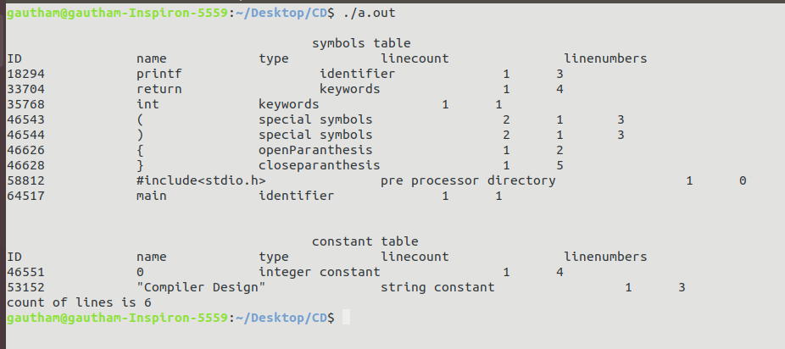
Example 2 Code:
#include<stdio.h>
int main()
{
int a=10;
printf("lucky number is %d",a);
return 0;
}

Screenshot
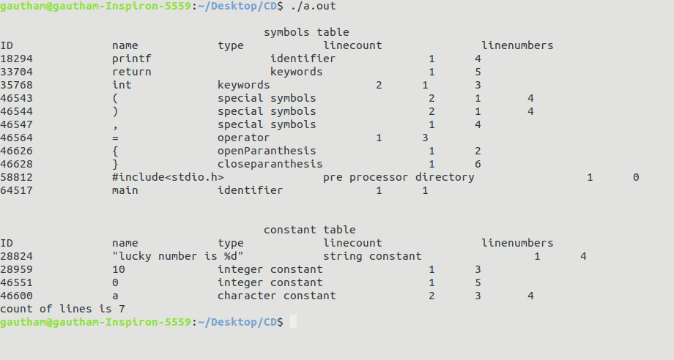
Example 3 Code:
#include<stdio.h>
int main()
{
//i am a student of NITK.
/*Currently
in 6th semester.
aah!!!*/
float inta;
scanf("%d",&inta);
return 0;
}

Screenshot
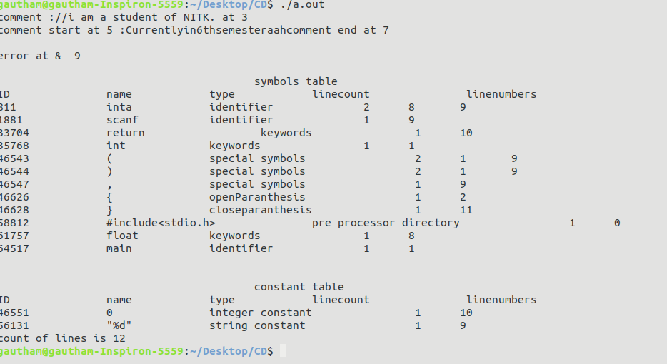
Example 4 Code:
#include<stdio.h>
int main()
{
float abc=1.1.1;
int a = 0x0g;

printf("Compiler Design");
return 0;
}

Screenshot
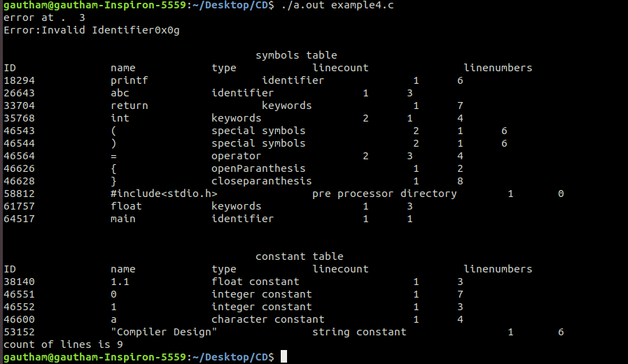
Example 5 code
#include<stdio.h>
int main()
{
char c[10]="ab\qcd";
int a[100];
for(int n=0;n<10;++n)
{
scanf("%d",&a[i]);
}
int ctr=0;
while(ctr<10)
{
printf("%d",a[i]);
++ctr;
}
printf("Compiler Design");
return 0;
}

Screenshot
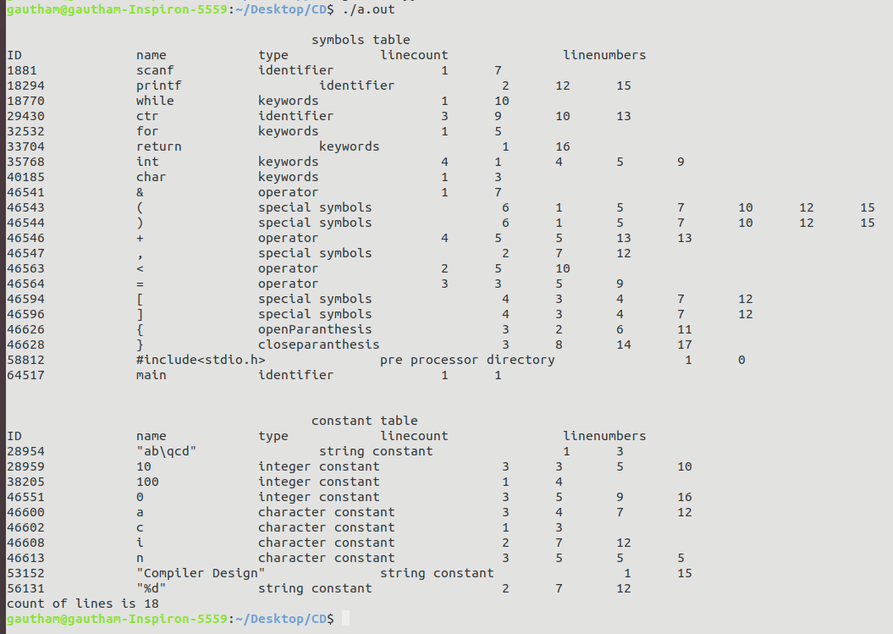

Example 6 Code:
#include<stdio.h>
#define ABC 25
int main()
{
int abc=100;
int ABC;
printf("%d %d %d %d %d",abc-ABC,abc+ABC,abc*ABC,abc/ABC,abc%ABC);
printf("Compiler Design");
return 0;
}

Screenshot
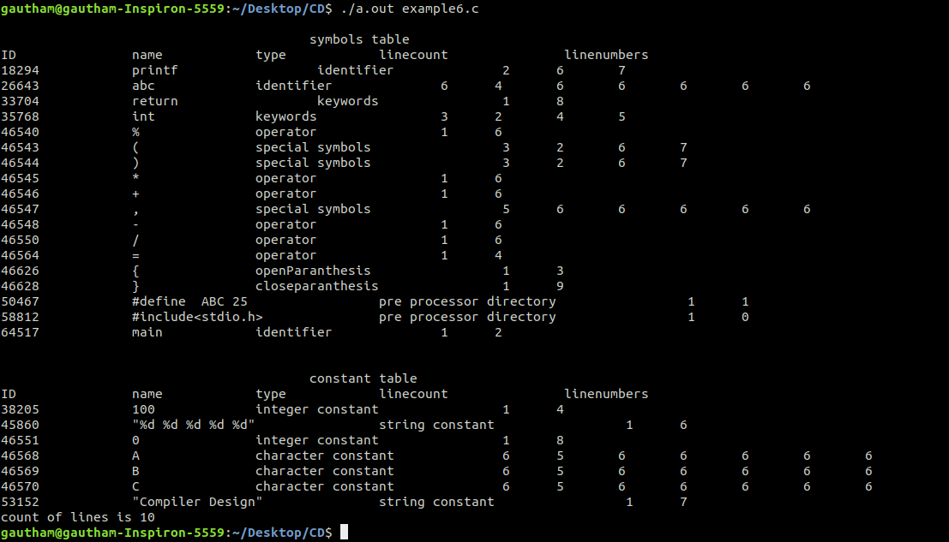
Example7 Code:
#include<stdio.h>
int add(int a,int b)
{
return a+b;
}
int main()
{
int a=10,b=23;
printf("lucky number is %d",a);
int a8b=add(a,b);
return 0;
}

Screenshot
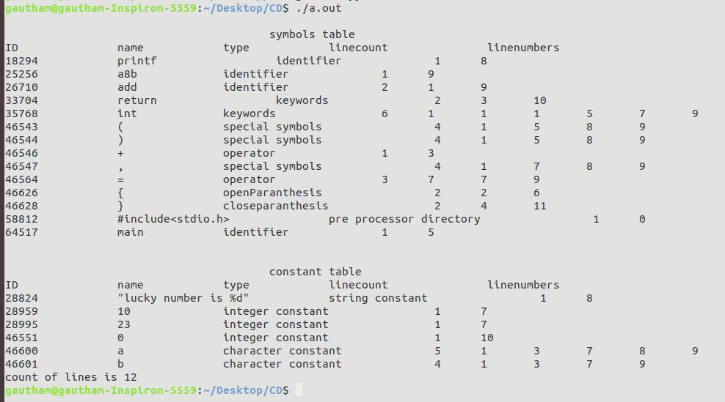

Example 8 Code:
#include<stdio.h>
int main()
{
//tester
/*boom
b
a*/
*/
/*
anda
*/

funct ();
int a1bc=0;
int a[100];
a1bc=a1bc+10;
int ;
int;
printf("\n abc %d",a1bc);

return 0;
}

Screenshot
